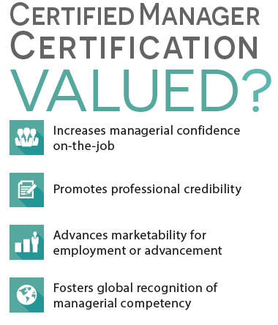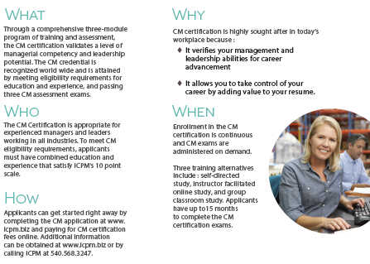

**Professional Development Opportunity**

**Certified Manager Program**



The 2024 Certified Manager (CM) Program will be starting again on the Wednesday May 1st. This program is open to all LM employees and this year we are inviting all NMA members to participate. The Certified Manager Program is a professional training program sponsored by the Institute of Certified Professional Managers (ICPM), which is an educational institute of James Madison University. The Certified Manager Program is a comprehensive, 3-module program of training and assessment that certifies a level of management competency and leadership potential which is recognized worldwide.

More than 14,000 professionals worldwide have been certified, including, in the last 15 years, over 250 Certified Managers in Moorestown alone. The CM Program in Moorestown is sponsored by the local Lockheed Martin Leadership Association (LMLA) chapter.

Classes meet one night each week from 5:30 pm to 7:30 pm eastern time on Wednesdays for twenty one weeks of classes. Classes are available virtually. Classes will start on May 1st, 2024.

If you cannot attend one of the orientation sessions or have additional questions, contact:

Jacek (Jack) Brach at [jacek.brach@lmco.com](mailto:jacek.brach@lmco.com) Omar Perales at [omar.perales@lmco.com](mailto:omar.perales@lmco.com)

(O) 609-326-4731 (O) 856-722-4967

(M) 609-912-4350 (M) 856-266-2116

